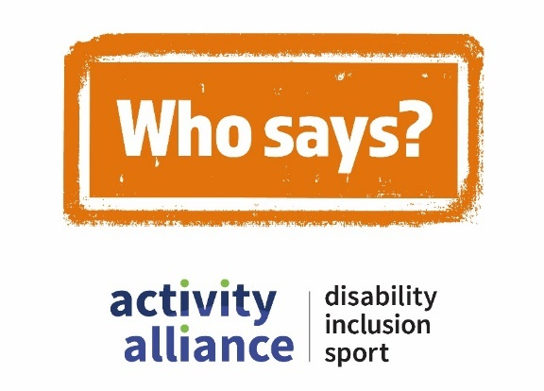

Transcript – Disabled people can’t be leaders film
This video shows action shots of disabled children and young people being active and playing different sports. While disabled and non-disabled children and adults talk about negative perceptions of disability, inclusion, and sport. It begins with quick scenes of people’s expressions, reactions, and responses to hearing the perception – Disabled people can’t be leaders.
School pupil, Rainbow: “No, I’m sorry I do not agree with that.”
Football player Matthew (brother): “Go on.” Football player Ally (sister): “I don’t know.”
Young video game player, Rocket shakes his head.
Rocket’s mum, Marti: “Wrong.”
Video game players, Rosie (sister) and Dylan (brother): “Yes they can! And I’d shout.”
Onscreen text and voiceover reads: “Disabled people can’t be leaders.”
Who says campaign logo appears onscreen with a stamping sound.
Voiceover: “Who says?”
Cut to shot of an under 16 age group pan-disability football session. Players run across an indoor pitch practicing their football skills.
Football coach, Shaun: “How can anybody say disabled young people can’t be leaders? Look at the world of sport, the Paralympics, everything. You see the most amazing people with a range of different disabilities. And all of them are leaders in their own right.”
Video game player, Dayton: “You can’t say that because you’re not the person who is disabled and you can’t boss that person around.”
Cut to shot of an inclusive dance class. Group of young disabled people follow choreography and dance to the music.
Dance teacher, Georgia: “Anyone else got a new move for the chorus? In this class, there are natural leaders, and we actually have a freestyle section at the end where they all take lead.”
Cut to shot of a parkour activity session. Visually impaired school pupils jump and roll on, over, and off soft boxes and obstacles.
School pupil, Rainbow: “I’m a massive leader in a project that I’m doing in school called ‘Sight Box’. And I’m going out to other universities, colleges, schools, primary schools over the last two years and taught other sighted people a lot of stuff.”
Cut to shot of a sport and activities event for young people with complex needs. Young people have fun on a climbing wall and zip wire.
Event organiser, Gemma: “They can be leaders more than anything. They can be role models for other young people that are taking part in sport. If they see that somebody like themselves is taking part in sport or physical activity then they will go on to do that.”
Dancer, Jamie: “You can do anything, that you put your mind to, and I would say go for it!”
Onscreen text and voiceover reads: “Call time on negative perceptions, #WhoSays.”
Who Says campaign logo appears onscreen with a stamping sound.
Video ends with Who Says campaign logo, Activity Alliance logo, and Sport England logo onscreen.
End of transcript.

