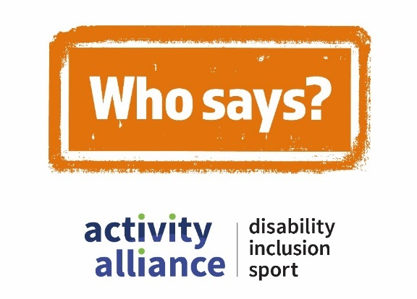

Transcript – Disabled children can’t grow up to be active adults film
This video shows action shots of disabled children and young people being active and playing different sports. While disabled and non-disabled children and adults talk about negative perceptions of disability, inclusion, and sport. It begins with quick scenes of people’s expressions, reactions, and responses to hearing the perception – Disabled children can’t grow up to be active adults.
Video game players Rosie (sister) and Dylan (brother): “No, no, nah.”
Charlotte, young girl in a wheelchair: “I think they’re wrong.”
PE teacher, Mr Green asks school pupil Rainbow: “You or me?”
School pupil, Ashley: “I think they can.”
Onscreen text and voiceover reads: “Disabled children can’t grow up to be active adults.”
Who says campaign logo appears onscreen with a stamping sound.
Voiceover: “Who says?”
Cut to shot of an inclusive gaming session. Children with a range of impairments play video games together.
Katie: “I would say yes they can be active when they’re older.”
Video game player, Dayton: “If you’re active as a kid, it will just grow out through your life.”
Gaming session organiser, Nicky: “If you are active as a child and you enjoy be active, there should be nothing to stop you as you get older.”
Cut to shot of an under 16 age group pan-disability football session. Players run across an indoor pitch playing a game of football.
Football coach, Shaun: “I was a child with a disability. I’ve grown up to be a football coach. It’s quite an active thing I’d say.”
Cut to shot of an inclusive dance class. Group of young disabled people follow choreography and dance to the music.
Dance teacher, Georgia: “They are more than capable to do anything. They can do what everyone else can and even sometimes more. Like Victoria is much more flexible. She can do the splits. I can’t do that.”
Cut to shot of a sport and activities event for young people with complex needs. Young people play games with hula hoops in a sports hall.
Event organiser, Gemma: “I think it’s about changing mindsets when it comes to activity, that it’s not just about you have to go to your sports club, you have to go to the gym. You can be active in the home, going out for a walk or you know being sociably active is still a way to be active.”
Cut back to shot of an inclusive dance class. Group of young disabled people follow choreography and dance to the music using colourful scarves.
Dance teacher, Rashmi asks dancer Alban: “So do you want to become a professional dancer?
Alban: “Oh yes, yes. Because I do hip hopping, street dancing, jazz, anything so yes.”
Rashmi: “So maybe you could be a teacher one day as well?”
Alban: “Yes, definitely!”
Onscreen text and voiceover reads: “Call time on negative perceptions, #WhoSays.”
Who Says campaign logo appears onscreen with a stamping sound.
Video ends with Who Says campaign logo, Activity Alliance logo, and Sport England logo onscreen.
End of transcript.

